《六六顺餐饮管理系统》安装手册
之MySQL数据库安装

1.install mysql sever 5.5, mysql-essential-5.5.5-m3-win32.msi
Note:
<1>. Change Install path to D:
<2>.Change storage path
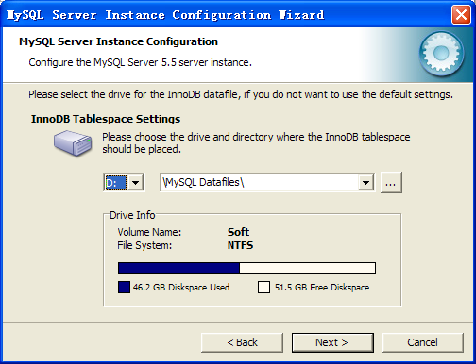

<3>. 3306 port pass to firewall
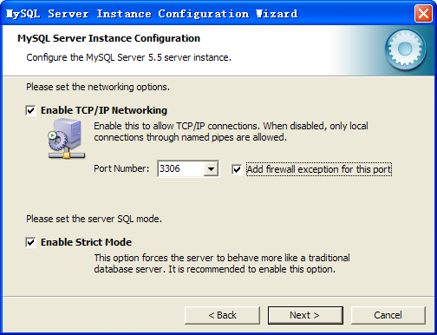
<4>. enable launch the MySQL Server automatically
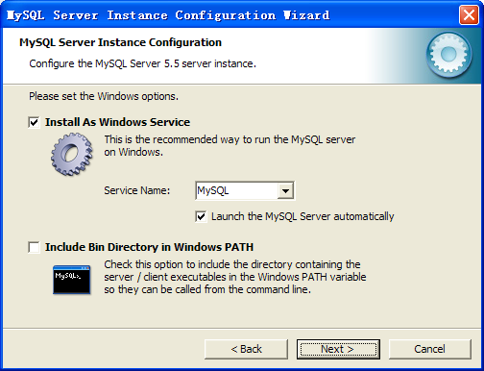
<5>. Set root password,and Enable root access from remote machines.
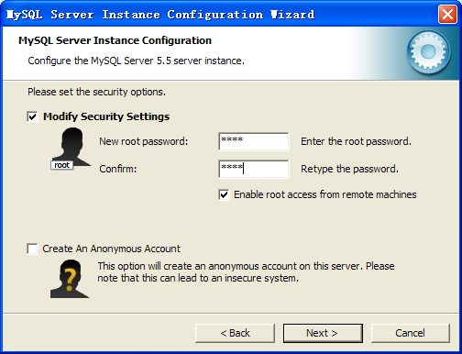

2.install mysql ODBC connector, mysql-connector-odbc-5.3.2-win32.msi
3.install navicat, navicat110_premium_cs_x86.exe

- run navicat and modify root password.
<1>.Creat MySQL Connect.
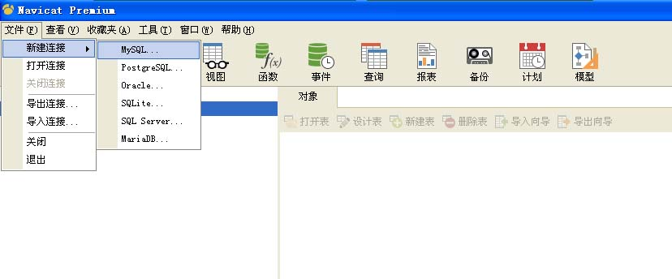

<2>.Configure SQL connection parameter
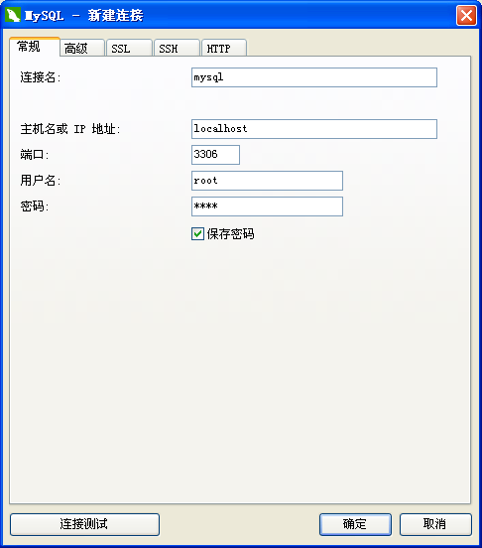

<3>.Open conntion and select mysql database ,and then run this commands;

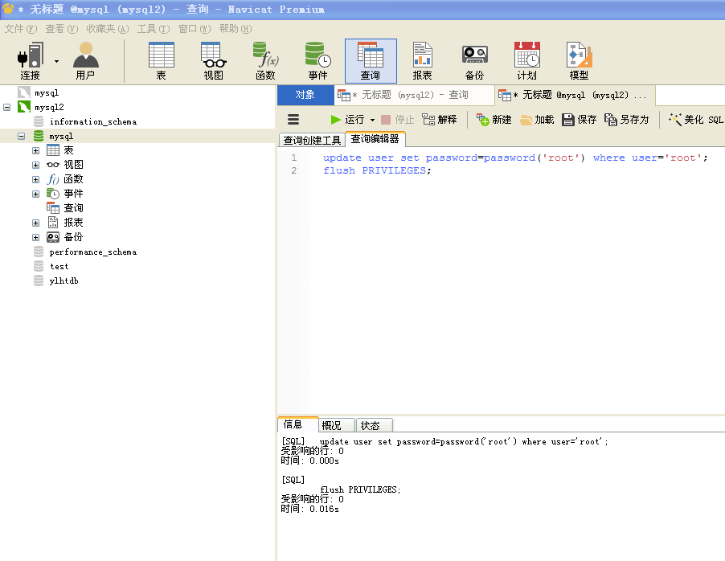
update user set password=password('root') where user='root';
flush PRIVILEGES;

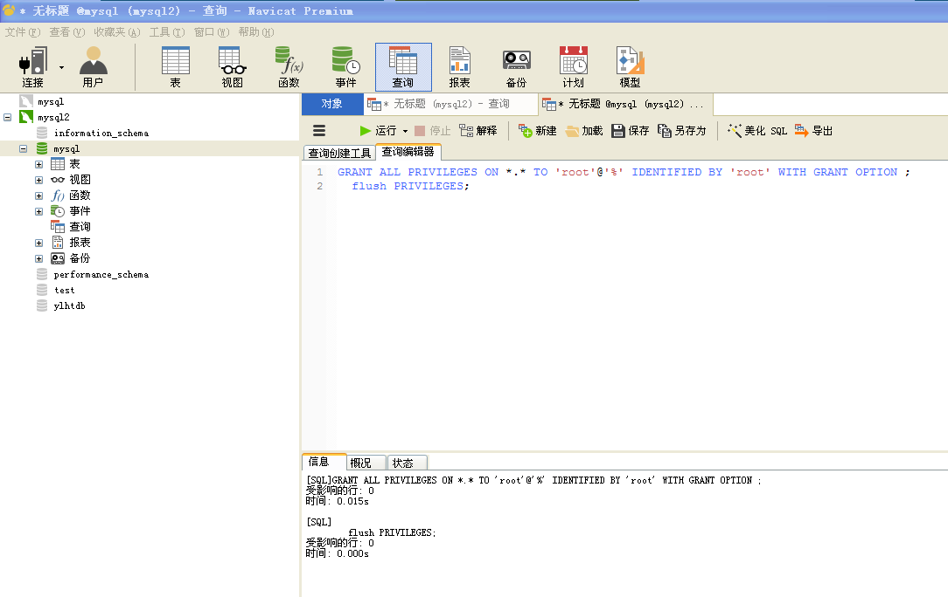
GRANT ALL PRIVILEGES ON *.* TO 'root'@'%' IDENTIFIED BY 'root' WITH GRANT OPTION ;
flush PRIVILEGES;

- Modify my.ini(mysql system dir) C:\Program Files\MySQL\MySQL Server 5.5
add this for MySQL Server [mysqld]
skip-name-resolve
lower_case_table_names=1
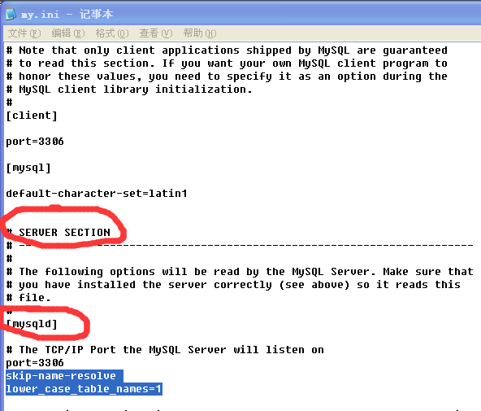

- My Computer, system environment add mysql path, path ;C:\Program Files\MySQL\MySQL Server 5.5\bin
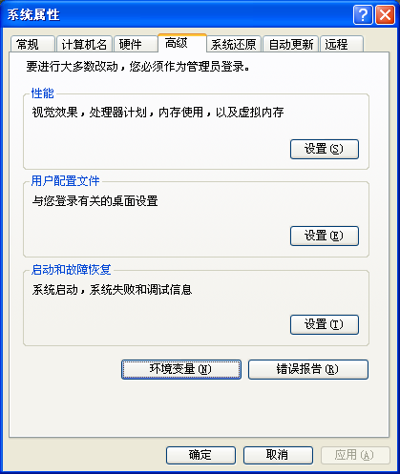
环境变量 ，系统变量，找到PATH，在最后面增加MySQL程序目录（;C:\Program Files\MySQL\MySQL Server 5.5\bin）。注意：在原值尾加 “;”
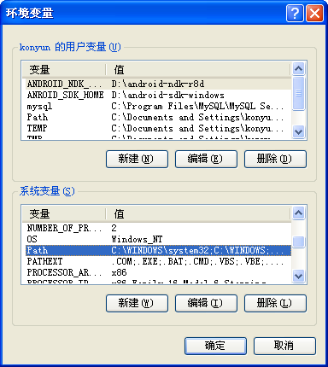

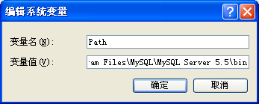

- Reboot Computer

8.Install RMS.

